
JBoss Portal
JBPM 5
SOA-P-DS
BRMS
DATA
SERVICES
JON

Red Hat
Six Products Demo (RH6PD)
BRMS DEMO GUIDE
BRMS & JBPM

The Intelligent Integrated Enterprise
A JBoss Standard Operating Environment

Version History
Version | Author | Date | Comments
0.1 | Derek Howlett | 21st January 2013 | First Draft
0.2 | Derek Howlett | 25th January 2013 | Updated screen-shots of new UI
0.3 | Derek Howlett | 31st January 2013 | Updated installation instructions

Table of Contents
Introduction 4
Demo Installation - Setup and Configuration 5
Install Prerequisites 5
Installation files 5
Download the RH6PD-CARINSURANCE-DEMO ZIP file. 6
Download JBoss Business Rules Management Platform (BRMS 5.3.1) 6
Download JBoss Application Server 6.0.1 7
Run the rh6pd-carinsurance-demo Install Script 7
Importing the RH6PD car insurance rules repository 8
Starting BRMS 8
Login to BRMS 8
Import RH6PD Demo Repository 8
Build the RH6PD Car insurance Package 9
An Overview of the Demo Components 10
The Data Model 10
The Customer (Driver) 10
The Vehicle (Car) 10
The Policy (The Result of the Insurance Application Process ) 11
The Business Process 12
Starting the business process 12
Step 1 - Script - Setting default environment variables 13
Step 2 – Human Task - Get Driver Information 14
Step 3 – Script - Set environment variables for entered driver information 15
Step 4 – Rule Execution - Run the rules for the driver risk calculation. 15
Step 5 – Human Task - Get Car Information 17
Step 6 – Human Task - Set environment variables for entered car information 17
Step 7 – Rule Execution - Run the rules for the car risk 18
Step 8 – Script – Update Rules 19
Step 9 – Rule Execution – Calculate Price 20
Step 10 – Script - Set Price 21
Step 11- Human Task – Review Policy 21
Step 12 – Rule Execution – Retract Objects. 22
The Demo Script 23
Web Browser Locations. 23
Navigate to the BRMS console http://localhost/jboss-brms 23
Navigate to the JBPM-CONSOLE 26
Navigate to the RH6PD web application 27
Click the START BRMS Demo button 28
Get Driver Form 31
Get Car Form 32
Review Policy Form 33
Retract Objects from Memory 34

Introduction
Welcome to the JBoss Middleware six products demonstration suite. If your new to JBoss middleware this suite of simple demos will allow you to get up and running with six of the most popular JBoss products very quickly.

This document describes the first of the Six Products Demos from JBoss Middleware. In this guide we will describe a business process for a simple car insurance quote. Essentially we will demonstrate how easy it is to build an I.T platform for selling car insurance. Although a simple representation of the actual insurance industry process it will cover all aspects of Enterprise architecture required to get to a fully functioning quote engine in place.

The car insurance quote is implemented with JBoss Business Rules Management System (BRMS). This version of BRMS also includes a powerful embeddable Business Process Management system which is used to control the business process .

Demo Installation - Setup and Configuration

Install Prerequisites

Component | Version Required.
JBoss Application Server | EAP 6.0.1
JBoss BRMS | BRMS 5.3.1
RH6PD Insurance Demo | RH6PD BRMS V0.1

Installation files
The RH6PD BRMS demo is delivered as a single ZIP file which must be expanded to reveal the following file :-
Component | Version Required
RH6PD JavaScript Web Application | webJsInterface.war
RH6PD BRMS DEMO EXPORT | repository.zip
RH6PD Data Model | Model.jar
RH6PD install directory | Install

Download the RH6PD-CARINSURANCE-DEMO ZIP file.
First you need to extract the demo distribution zip (rh6pd-carinsurance-demo-0.1.zip) to a location of your choosing . Once extracted, you will have the following folder structure:
- rh6pd-carinsurance-demo.zip
  - installs – Initially empty, but will be where you place the EAP & BRMS platform downloads from access.redhat.com.
  - projects – The project that comprise the demo.
  - support – Additional supporting files used by the demo.
  - target – Will be created by running rh6pd-install.sh. This directory will contain the fully configured BRMS runtime server.
  - rh6pd-install.sh – Script to install and configure the run time server environment.
  - start – start script to start BRMS once installed.
  - RH6PD BRMS Demo Guide.odt – This document.
Why not set an environment variable to point to your install directory. If your using the bash shell the configuration should be in your $HOME/.bashrc

$export RH6PD-INSTALL=”$HOME/rh6pd-carinsurance-demo”

from now on the convention we will use is to refer to this install directory as:-

$RH6PD-INSTALL

Download JBoss Business Rules Management Platform (BRMS 5.3.1)

Download JBoss Enterprise BRMS Platform (JBoss BRMS 5.3.1 Deployable) from the Red Hat Customer Portal (https://access.redhat.com/jbossnetwork).
Download BRMS Platform:
- Under JBoss Enterprise Platforms, select the BRMS Platform product.
- Select version 5.3.1 in the Version field.
- Download JBoss BRMS 5.3.1 Deployable for EAP 6
(Please note that this is the deployable distribution, not the standalone one.)

Now copy brms-p-5.3.1.GA-deployable-ee6.zip, to the rh6pd-carinsurance-demo installs folder $RH6PD-INSTALL/installs.

$RH6PD-INSTALL/installs/brms-p-5.3.1.GA-deployable-ee6.zip

Download JBoss Application Server 6.0.1

Download EAP 6 Platform:
- Under JBoss Enterprise Platforms, select the Application Platform product.
- Select version 6.0.1 in the Version field.
- Download JBoss Aplication Platform 6.0.1

Now copy jboss-eap-6.0.1.zip, to the rh6pd-carinsurance-demo's installs folder. $RH6PD-INSTALL,

$RH6PD-INSTALL/installs/jboss-eap-6.0.1.GA.zip

Run the rh6pd-carinsurance-demo Install Script

Now from the $RH6PD-INSTALL/rh6pd-carinsurance-demo folder run the install script:

$ ./install.sh

When the script completes you will have a new folder named jboss-eap-6.0, in the rh6pd-carinsurance-demo's $RH6PD-INSTALL/target folder.

The folder is a ready to run EAP 6 server with BRMS 5.3.1 with the following modifications have been made:

- The admin account is enabled (password is admin) in the brms-roles.properties and brms-users.properties file in rh6pd-carinsurance-demo/target/jboss-eap-6.0/jboss-as/standalone/configuration

- The security settings are modified by copying components.xml to :-
$RH6PD-INSTALL/target/jboss-eap-6.0/standalone/deployments

- Adjusted server security domain to include brms, copied new standalone.xml to $RH6PD-INSTALL/target/jboss-eap-6.0/jboss-as/standalone/configuration

- The domain model jar Model.jar added to the console at $RH6PD-INSTALL/target/jboss-eap-6.0/deployments/jbpm-gwt-console-server.war/WEB-INF/lib

- Human Task users are enabled by copying a new jbpm-human-task-war-web.xml file to $RH6PD-INSTALL/target/jboss-eap-6.0/jboss-as/standalone/deployments/jbpm-human-task.war/WEB-INF/web.xml

- Both business-central-server and jbpm-human-task server needs a netty dependency, added a MANIFEST.MF to their repective WEB-INF/classes/META-INF directories

- The various testing dependencies will be unzipped and copied into rh6pd-carinsurance-demo/support/lib/*

- Deploy RH6PD JavaScript demo web application – rh6pd-webJsInterface.war into the deployment directory. The webJsInterface.war file has been unzipped and copied into the rh6pd-carinsurance-demo/server/default/deploy directory.

Importing the RH6PD car insurance rules repository

In this final step you will need to start BRMS and import the car insurance repository.

Starting BRMS

Open a terminal window and execute the following command.
$RH6PD-INSTALL/target/ jboss-eap-6.0/bin/standalone.sh
or use the provided start script:-

./start

This will start the application server and deploy and start BRMS and the rh6pd car insurance demo web application.

Login to BRMS

Next navigate your browser to http://localhost:8080/jboss-brms, log in as admin/admin
the BRMS guvnor web interface is displayed.

Import RH6PD Demo Repository

On the left hand navigation panel expand Administration

Select Import/Export. The import export form is displayed. Browse to the $RH6PD-INSTALL/repository.zip file which is included in the demo distribution.

Click Import.

Build the RH6PD Car insurance Package
Now using the side navigation panel , browse to the Knowlegde Base. Expand the packages org.jbpm.evaluation.carinsurnace to reveal the list of assets.

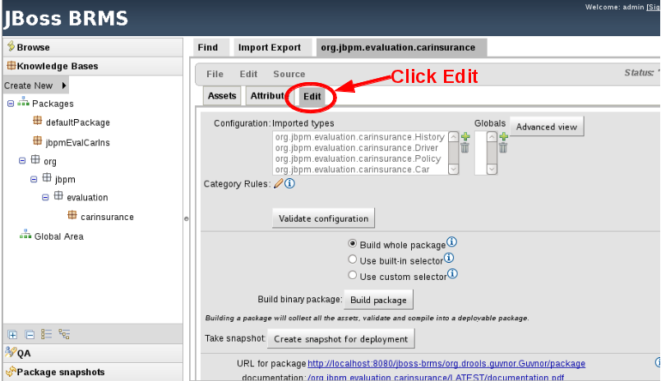

Once your in the edit area of the package you can now validate and build the package.
Click Validate configuration, wait for the small green tick and Package validated successfully to be displayed at the top.
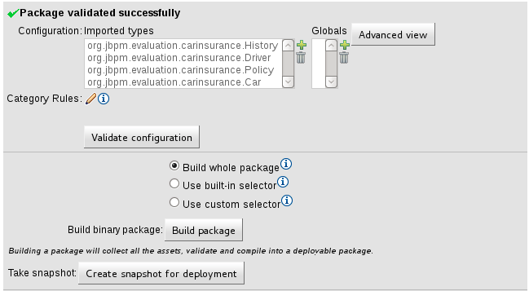

Now click build package to complete the build process.

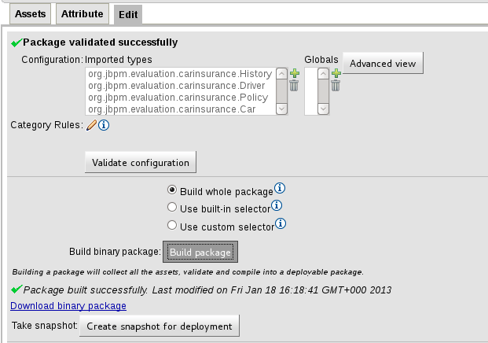

An Overview of the Demo Components

The Data Model

A distinct and carefully designed data model can make your business and subsequent I.T systems very much easier to manage. Data modelling is often refereed to as the year two problem when systems are integrated together; there is a sudden realisation that the data on every system is formatted differently.

A well-designed and managed data model, which is implemented up front can save time, money and therefore reduce the costs of running your business.

For our six products demonstration we will design a very simple data model, make links between the component parts and deploy into a central business repository.

- Note The RH6PD car insurance demo includes a data model, essentially a set of Java class files that represent the objects as facts. The Model must be present in the BRMS repository and the class path of the application server.

The Customer (Driver)

This is the entity which represents our customer, for the car insurance quote our customer is defined by a simple object called “Driver”.

Driver looks like the following: -

Driver
Description | Type
Name | String
Address | Object
Age | Integer
Social Security Number | String
Driving Licence Number | String
Credit Score | Integer

The Vehicle (Car)

This is the entity which represents the vehicle being insured, for our car insurance quote the vehicle is defined by a simple object called “Car”.

Car looks like the following:-

Description | Type
Make | String
Model | String
Year | Integer
Registration Number | String

The Policy (The Result of the Insurance Application Process )

This is the entity which represents the insurance quote itself, this is defined by a simple object called “Policy”.

Policy looks like the following:-

Description | Type
Policy Number | Integer
Policy Date | Date
Named Driver | String
Address | Object Address
Car Registration Number | String
Total Risk | Integer
Driver Risk | Integer
Car Risk | Integer
History Risk | Integer
Price | Currency
Discount

The Business Process

This section describes in some detail the business process and the steps involved in generating an insurance quote. If your just looking for instructions on running the demo, please jump to the next chapter “Demo Script”.

There are three sets of rules which are used to calculate the policy price, the risk of the drive, the risk of the car and finally the pricing rule used to match the driver and car to determine the final price.

There are three human tasks used in the business process. Asking for information about the driver, asking for information on the car and finally the review police human task which we use to review all the details entered and display the final policy price.

Starting the business process
You can start this car insurance business process from the JBPM-CONSOLE simply by selecting the Quote222 and clicking start. You will be presented with a standard start form generated from the BPMN2.0 code. You will then need to complete the tasks from the tasks menu of the JBPM-CONSOLE.
Preferred....
Or by using the JavaScript application shipped with this demo. Go to http://localhost:8080/rh6pd and follow the instructions listed in the Demo Script section of this demo.

Step 1 - Script - Setting default environment variables
System.out.println("*** Starting Set Driver ***");

// Set variables
driverRisk="Set Driver: Not Set Yet";
driver = new Driver();
policy = new Policy();

// Set policy object with default values
policy.setDriverRisk(999);
policy.setPrice(999);

// Set driver object up with variable required for firing rules.
driver.setCreditScore(999);
driver.setName(name);
driver.setAge(Integer.parseInt(age));

//Insert into session.
kcontext.setVariable("driver",driver);
kcontext.setVariable("policy",policy);
kcontext.setVariable("name",name);
kcontext.setVariable("address1",address1);
kcontext.setVariable("address2",address2);
kcontext.setVariable("age",age);
kcontext.setVariable("driverRisk",driverRisk);

// Insert into working memory
insert(driver);
insert(policy);

System.out.println("*** Exiting Set Driver ***");</script>
</scriptTask>
<scriptTask id="_17" name="SetDefaultVariables" >
<script>

// Set Variables
name ="SetCar: Not Set Yet";
address1="SetCar: Not Set Yet";
address2="SetCar: Not Set Yet";
age="SetCar: Not Set Yet";

make ="SetCar: Not Set Yet";
model ="SetCar: Not Set Yet";
reg ="SetCar: Not Set Yet";
year =1999;

driverRisk="SetCar: Not Set Yet";
carRisk="SetCar: Not Set Yet";

// Driver
kcontext.setVariable("name",name);
kcontext.setVariable("address1",address1);
kcontext.setVariable("address2",address2);
kcontext.setVariable("age",age);

//Car
kcontext.setVariable("make",make);
kcontext.setVariable("model",model);
kcontext.setVariable("reg",reg);
kcontext.setVariable("year",year);

// Risks
kcontext.setVariable("carRisk",carRisk);
kcontext.setVariable("driverRisk",driverRisk)

Step 2 – Human Task - Get Driver Information
This is the step in the process where we collecting information about the driver. This task is a human task and is delegated to the human task server which generates a form for the user to complete.
<userTask id="_4" name="GetDriver" >
<ioSpecification>
<dataInput id="_4_CommentInput" name="Comment" />
<dataInput id="_4_SkippableInput" name="Skippable" />
<dataInput id="_4_TaskNameInput" name="TaskName" />
<dataInput id="_4_GroupIdInput" name="GroupId" />
<dataInput id="_4_PriorityInput" name="Priority" />
<dataOutput id="_4_NameOutput" name="Name" />
<dataOutput id="_4_AgeOutput" name="Age" />
<dataOutput id="_4_Address2Output" name="Address2" />
<dataOutput id="_4_Address1Output" name="Address1" />
<inputSet>
<dataInputRefs>_4_CommentInput</dataInputRefs>
<dataInputRefs>_4_SkippableInput</dataInputRefs>
<dataInputRefs>_4_TaskNameInput</dataInputRefs>
<dataInputRefs>_4_GroupIdInput</dataInputRefs>
<dataInputRefs>_4_PriorityInput</dataInputRefs>
</inputSet>
<outputSet>
<dataOutputRefs>_4_NameOutput</dataOutputRefs>
<dataOutputRefs>_4_AgeOutput</dataOutputRefs>
<dataOutputRefs>_4_Address2Output</dataOutputRefs>
<dataOutputRefs>_4_Address1Output</dataOutputRefs>
</outputSet>
</ioSpecification>
…...
</userTask>

Step 3 – Script - Set environment variables for entered driver information
This step in the process is used to create the driver and policy objects, set driver variables to default values and the insert the driver and policy setup a number of environment variables to default values.
// Set variables
driverRisk="Set Driver: Not Set Yet";
driver = new Driver();
policy = new Policy();

// Set policy object with default values
policy.setDriverRisk(999);
policy.setPrice(999);

// Set driver object up with variable required for firing rules.
driver.setCreditScore(999);
driver.setName(name);
driver.setAge(Integer.parseInt(age));

//Insert into session.
kcontext.setVariable("driver",driver);
kcontext.setVariable("policy",policy);
kcontext.setVariable("name",name);
kcontext.setVariable("address1",address1);
kcontext.setVariable("address2",address2);
kcontext.setVariable("age",age);
kcontext.setVariable("driverRisk",driverRisk);

// Insert into working memory
insert(driver);
insert(policy);

Step 4 – Rule Execution - Run the rules for the driver risk calculation.
This step of the process simply calls the rules in the calcDriverRisk decision table. This is done with the following ruleflowgroup statement.

<businessRuleTask id="_6" name="CalcDriverRisk" g:ruleFlowGroup="calcDriverRisk" >

From the BRMS user interface, expand the rules tab to see the calc Driver risk table.
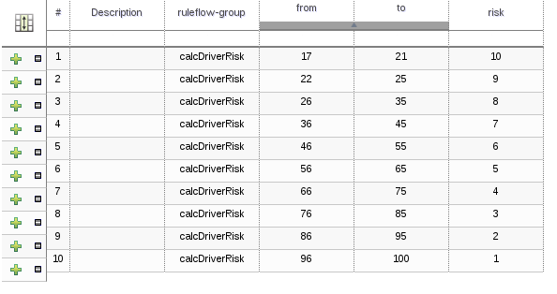

Once you have the table displayed you can see the actual rules generated by the decision table by selecting source tab then clicking View Source.

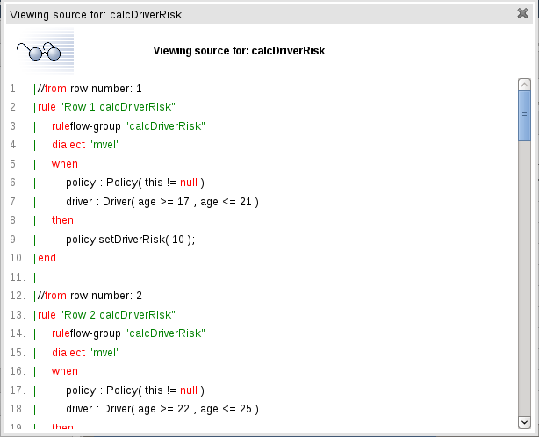

Step 5 – Human Task - Get Car Information
This is the step in the process where we collecting information about the car. This task is a human task and is delegated to the human task server which generates a form for the user to complete.
<userTask id="_13" name="GetCar" >
<ioSpecification>
<dataInput id="_13_TaskNameInput" name="TaskName" />
<dataInput id="_13_GroupIdInput" name="GroupId" />
<dataOutput id="_13_YearOutput" name="Year" />
<dataOutput id="_13_ModelOutput" name="Model" />
<dataOutput id="_13_RegOutput" name="Reg" />
<dataOutput id="_13_MakeOutput" name="Make" />
<inputSet>
<dataInputRefs>_13_TaskNameInput</dataInputRefs>
<dataInputRefs>_13_GroupIdInput</dataInputRefs>
</inputSet>
<outputSet>
<dataOutputRefs>_13_YearOutput</dataOutputRefs>
<dataOutputRefs>_13_ModelOutput</dataOutputRefs>
<dataOutputRefs>_13_RegOutput</dataOutputRefs>
<dataOutputRefs>_13_MakeOutput</dataOutputRefs>
</outputSet>
</ioSpecification>....
</userTask>

Step 6 – Human Task - Set environment variables for entered car information
Once the human task for get Car has completed the resulting variables must be mapped back into the environment. The car object is created, variable are coppied in from the form and the policy object is updated.
System.out.println("create new car");
car = new Car();

// Set policy object with default values
System.out.println("set car risk to 999");
policy.setCarRisk(999);

// Set car object up with variable required for firing rules.
car.setMake(make);
car.setModel(model);
car.setReg(reg);

//Insert into session.
kcontext.setVariable("car",car);
kcontext.setVariable("make",make);
kcontext.setVariable("model",model);
kcontext.setVariable("reg",reg);
kcontext.setVariable("year",year);
kcontext.setVariable("carRisk",carRisk);
kcontext.setVariable("driverRisk",driverRisk);

// Insert into working memory
insert(car);
kcontext.getKnowledgeRuntime().update(kcontext.getKnowledgeRuntime().getFactHandle(policy), policy);

Step 7 – Rule Execution - Run the rules for the car risk
This step of the process simply calls the rules in the calcCarRisk decision table. This is done with the following ruleflowgroup statement.

<businessRuleTask id="_14" name="CalcCarRisk" g:ruleFlowGroup="calcCarRisk" >
</businessRuleTask>

From the BRMS user interface, expand the rules tab to see the calc Car risk table.
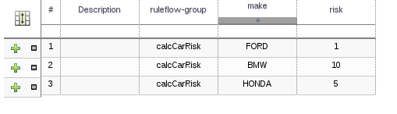

Once you have the table displayed you can see the actual rules generated by the decision table by selecting source tab then clicking View Source.

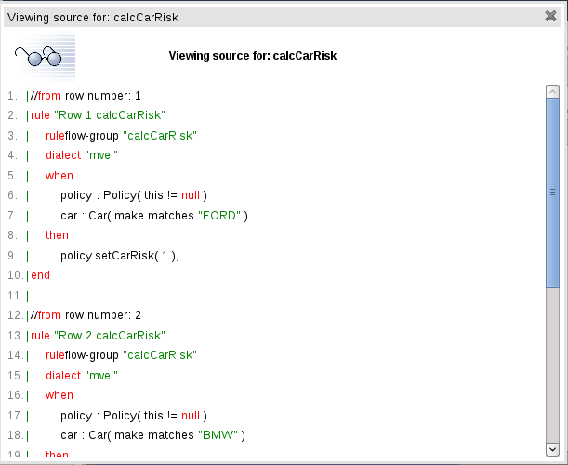

Step 8 – Script – Update Rules
Setup the policy and update the rules engine to take into account
A feature of the BRMS rules engine is when the process is loaded for the first time all the rules defined in the car insurance package fire with the intent to calculate the price. Of course at the beginning of the process there is no data loaded into the facts. As we progress through the process we create a driver object which forces the rules to fire once again, this sets the driver risk. We then create the car object which again forces the rules to fire, this time setting the car risk.
At step 8 we have the driver and car risks set in the policy, but the rules engine doesn't have any way that the calcPrice rule now needs to be fired. So we execute the following statements at step 8 to retrieve the policy risk components and then force the policy rules to fire.

// Get variables
driverRiskInt = policy.getDriverRisk();
driverRisk = new Integer (driverRiskInt).toString();

kcontext.getVariable("policy"));

carRiskInt = policy.getCarRisk();
carRisk = new Integer (carRiskInt).toString();

// Update working memory
kcontext.getKnowledgeRuntime().update(kcontext.getKnowledgeRuntime().getFactHandle(policy), policy);

Step 9 – Rule Execution – Calculate Price
This step of the process simply calls the rules in the calcPrice decision table. This is done with the following ruleflowgroup statement.
<businessRuleTask id="_11" name="CalcPrice" g:ruleFlowGroup="calcPrice" >
</businessRuleTask>

From the BRMS user interface, expand the rules tab to see the calc Price decision table.
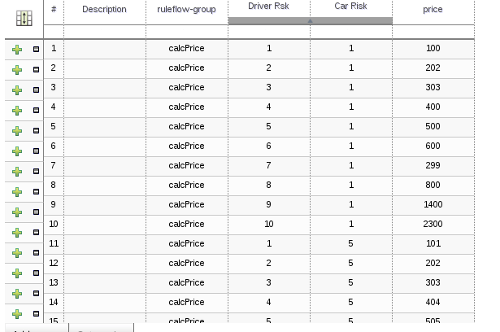

Once you have the table displayed you can see the actual rules generated by the decision table by selecting source tab then clicking View Source.
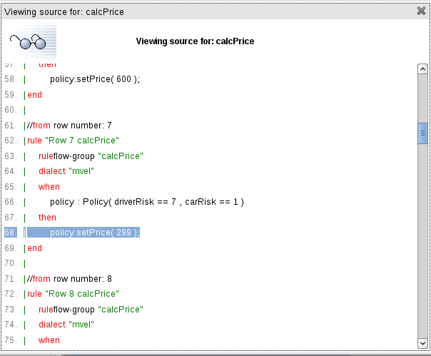

Step 10 – Script - Set Price
A script which sets up environment variables based on the result of calculating the price in the previous steps.

// set variables
price="Not Set Yet";
// get variables
price=new Integer(policy.getPrice()).toString();

driverRisk=new Integer(policy.getDriverRisk()).toString();
carRisk=new Integer(policy.getCarRisk()).toString();

// set variables.
kcontext.setVariable("name",name);
kcontext.setVariable("address1",address1);
kcontext.setVariable("address2",address2);
kcontext.setVariable("age",age);
kcontext.setVariable("driverRisk",driverRisk);
kcontext.setVariable("carRisk",carRisk);
kcontext.setVariable("price",price);
kcontext.setVariable("make",make);
kcontext.setVariable("model",model);

Step 11- Human Task – Review Policy
This step is used to generate a form which reviews the details of the policy. This includes driver and car information and the final calculated price.

Should should accept the quote to force the process to the final step 12. retract.

<userTask id="_B09AA1BF-19DA-4F57-B074-F36CB7E94178" name="ReviewPolicy" >
<ioSpecification>
<dataInput id="_B09AA1BF-19DA-4F57-B074-F36CB7E94178_NameInput" name="Name" />
<dataInput id="_B09AA1BF-19DA-4F57-B074-F36CB7E94178_AgeInput" name="Age" />
<dataInput id="_B09AA1BF-19DA-4F57-B074-F36CB7E94178_ModelInput" name="Model" />
<dataInput id="_B09AA1BF-19DA-4F57-B074-F36CB7E94178_DriverRiskInput" name="DriverRisk" />
<dataInput id="_B09AA1BF-19DA-4F57-B074-F36CB7E94178_Address2Input" name="Address2" />
<dataInput id="_B09AA1BF-19DA-4F57-B074-F36CB7E94178_Address1Input" name="Address1" />
<dataInput id="_B09AA1BF-19DA-4F57-B074-F36CB7E94178_PriceInput" name="Price" />
<dataInput id="_B09AA1BF-19DA-4F57-B074-F36CB7E94178_CarRiskInput" name="CarRisk" />
<dataInput id="_B09AA1BF-19DA-4F57-B074-F36CB7E94178_MakeInput" name="Make" />
<dataInput id="_B09AA1BF-19DA-4F57-B074-F36CB7E94178_CommentInput" name="Comment" />
<dataInput id="_B09AA1BF-19DA-4F57-B074-F36CB7E94178_SkippableInput" name="Skippable" />
<dataInput id="_B09AA1BF-19DA-4F57-B074-F36CB7E94178_TaskNameInput" name="TaskName" />
<dataInput id="_B09AA1BF-19DA-4F57-B074-F36CB7E94178_GroupIdInput" name="GroupId" />
<dataInput id="_B09AA1BF-19DA-4F57-B074-F36CB7E94178_PriorityInput" name="Priority" />
<inputSet>
…..
</userTask>

Step 12 – Rule Execution – Retract Objects.

The final step in the process is labelled as retract, here we call a group three of rules,

Rule | Description
RetractDriver | Removes the car object from the working memory of the rules engine.
RetractCar | Removes the car object from the working memory of the rules engine.
RetractPolicy | Removes the policy object from the working memory of the rules engine.

The Demo Script
Starting the demonstration

Web Browser Locations.
Connect to BRMS console | http://localhost:8080/jboss-brms | admin/admin
Connect to JBPM-console | http://localhost:8080/business-central/app.html | admin/admin
Open Home page for RH6PD | http://localhost:8080/rh6pd
Start Quote Processs | http://localhost:8080/rh6pd/quote.html
Retrive Tasks from Process | http://localhost:8080/rh6pd/tasks.html

Navigate to the BRMS console http://localhost/jboss-brms
login as admin/admin
navigate to the car insurance package org.evaluation.jbpm.carinsurance

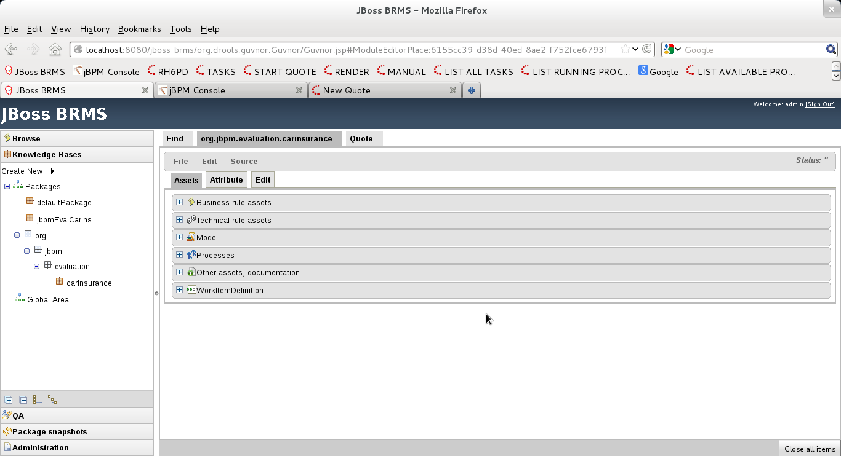
open the process show the process in the JBPM web designer
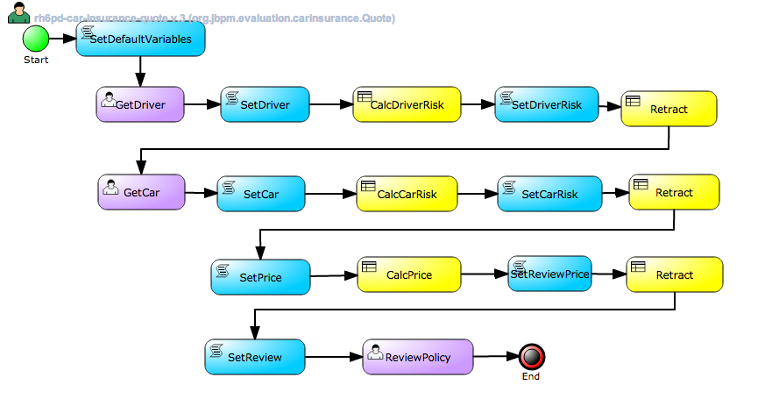
discuss the three human tasks

open rules tab
show calcDriverRisk to determine the risk of a 45 year old driver

show calcCarRisk to determine the risk for a Ford Fiesta

show calcPrice to determine the price for a for Driver risk of 7 and a car risk of 1
As you can see we are having a special deal on drivers with a risk of 7 and a car risk of 1, the price indicated shows 299. Watch out for this at the review policy step.

Navigate to the JBPM-CONSOLE
Login as admin/admin – expand the process tab to reveal the demo process
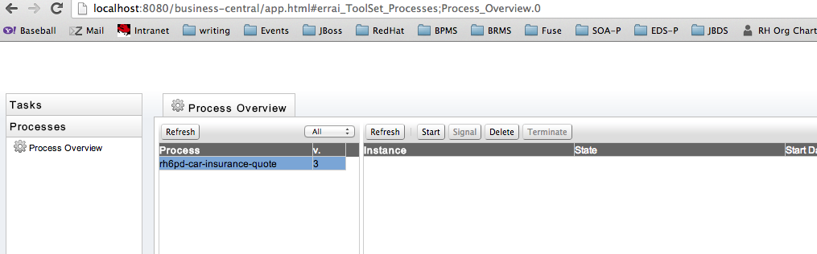

Navigate to the RH6PD web application
Your are now at the RH6PD demo home page.
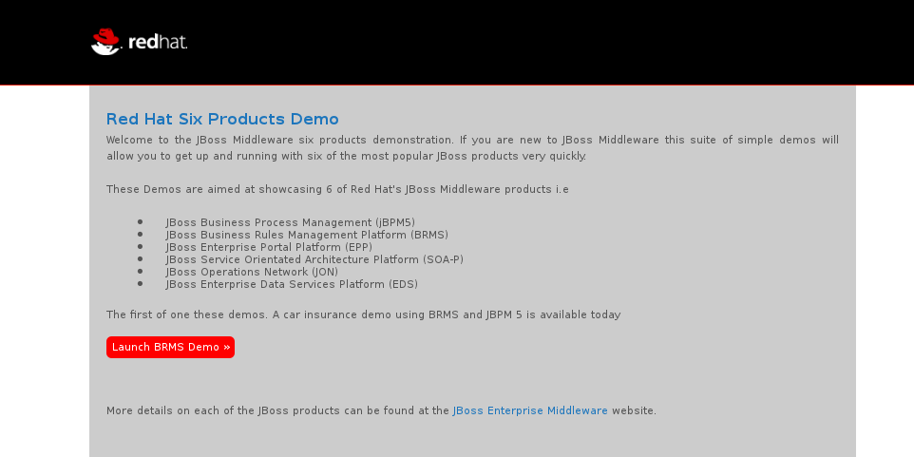

Click the START BRMS Demo button
You will be presented with the Quote process start screen.
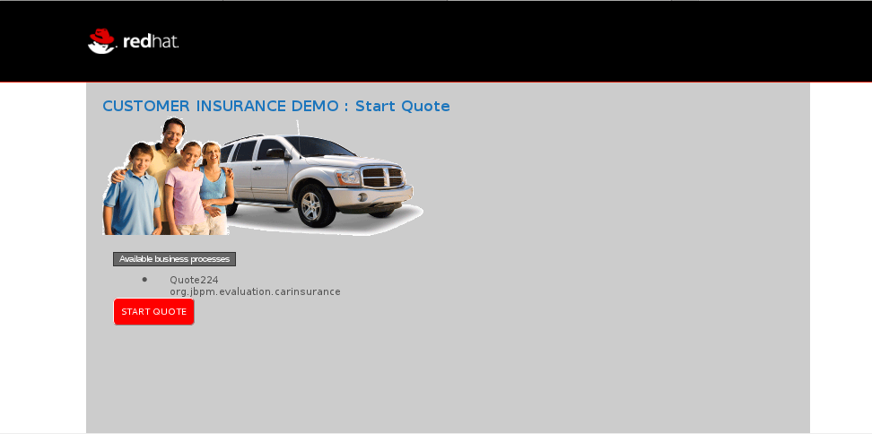
The Quote process start screen displays the current quote process available. If however you get the following message, this means you haven't authenticated with JBPM yet. Please go to the URL for the JBPM-CONSOLE and authenticate there.
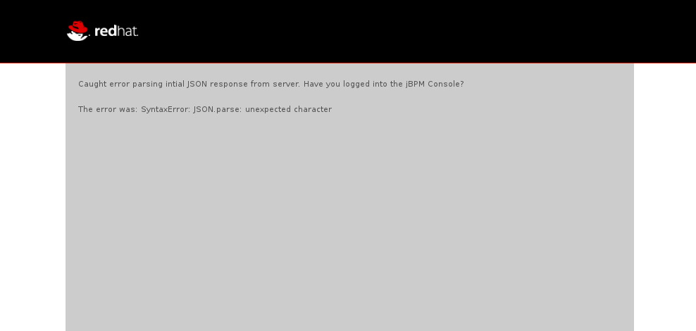

Get Driver Form

Clicking start on the Start Quote form will bring up the GetDriver form.

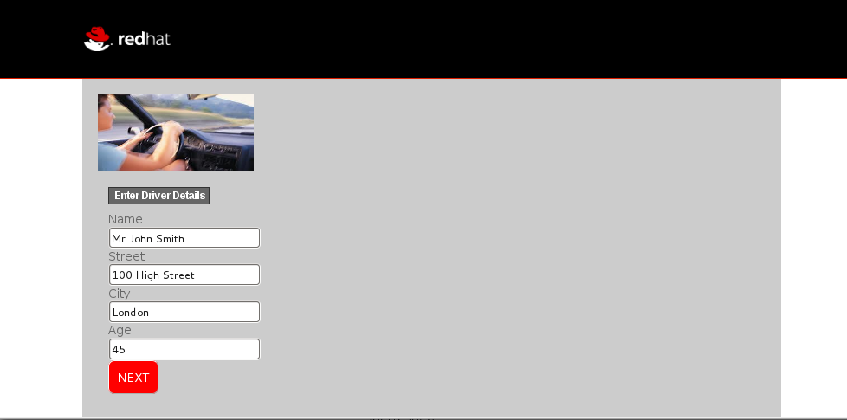
Once you have the Driver dialog on the screen, this is the point to switch tabs back to the JBPM-CONSOLE and this time selecting the running process and then the diagram box will bring up the process again but this time the image will have a red triangle indicating where you are in the process .

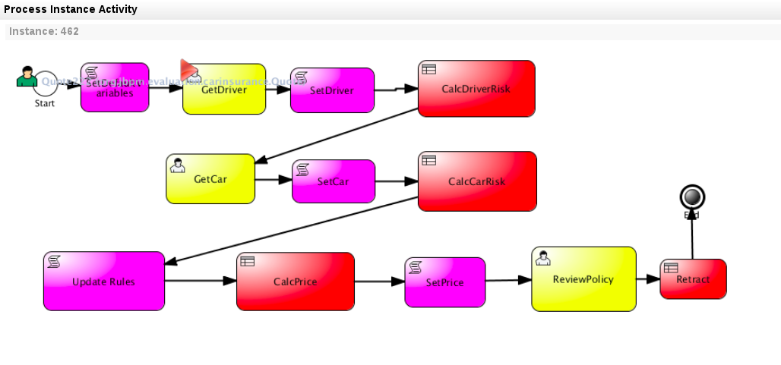

Get Car Form
Returning to the Driver form select default values have been inserted for ease of use. Currently a driver with an age with 45 is selected. Press NEXT to move to the Car form.

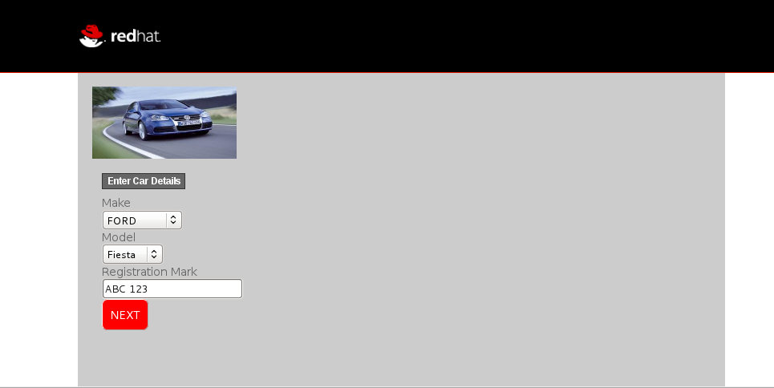
Now from the JBPM-CONSOLE you can now see the process has moved on to the getCar step.

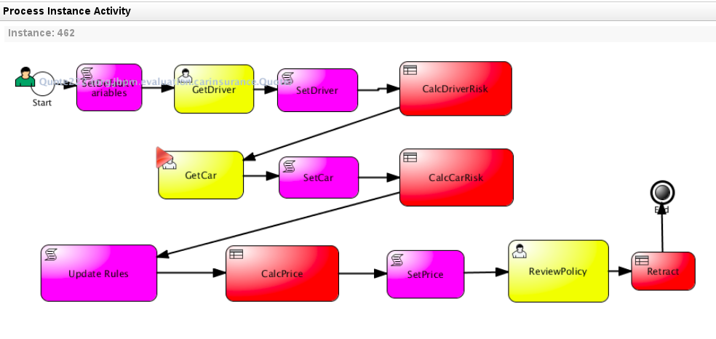
Select a FORD Fiesta from the drop down list and click NEXT.

Review Policy Form

The Final form displays the quote. This is the review policy step in the process.

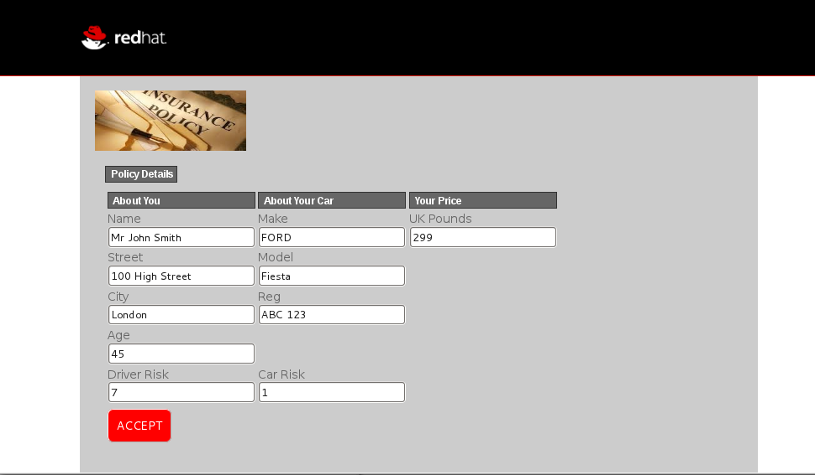
Again you can see the process has advanced to the review policy step.

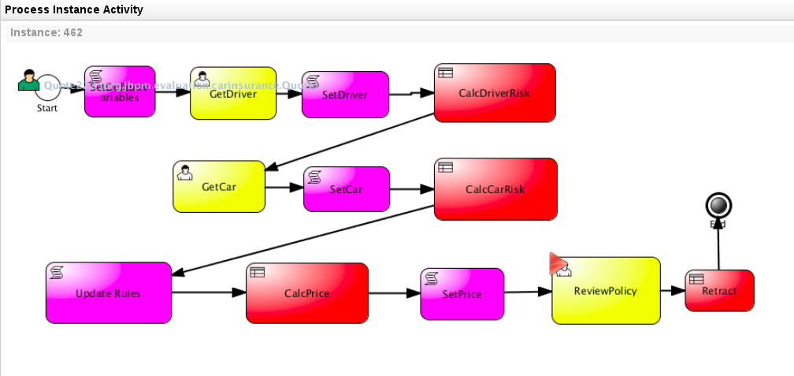

Retract Objects from Memory

From the window you started the BRMS from you should now see the log file detail the three retract statements.

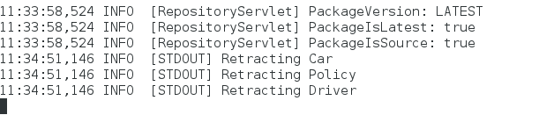

Once accepted the review policy will display the complete form.

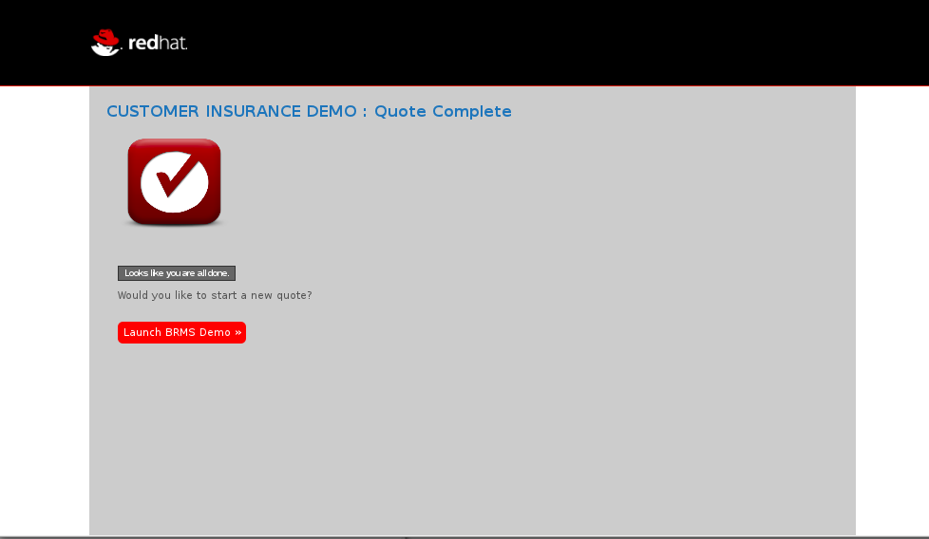
Click new_quote to step through the demo again, this time experiment with different driver ages and different car types to see the range of prices. You can edit the prices from the BRMS rules section, in the calcPrice decision table.

